Personal details
Last name |  |  |  |  | Phone |  |  |  |  |  |  |  |  |  |  | Approved  Date  Signature
First name |  |  |  |  | Fax
Address |  |  |  |  | E-mail
Postcode, town |  |  |  |  | Mobile
Country |  |  |  |  | Homepage
Bank account details
IBAN |  |  |  |  |  |  | VAT number
BIC
Bank name
Bank address
Invoicing information:

Invoices that you have submitted must be properly issued and comply with legal requirements.

Payment shall be made within 30 days upon receipt of the invoice, provided it complies with the specifications.

Please include the applicable Leinhäuser order/project number on the invoice.

Education
Higher education/Training |  |  |  |  |  |  |  |  | Degree |  |  |  |  |  |  |  | Year
Additional qualifications
Other qualifications |  |  |  |  |  |  |  |  | Comments |  |  |  |  |  |  |  | Year
Professional experience | since | As translator |  |  |  |  |  | since |  |  |  |  |  | Comments:
 |  | As  reviser |  |  |  |  |  | since
Language skills
Mother tongue | Other languages |  |  | Sworn languages |  |  |  |  |  |  | Comments
Areas of expertise
Software
Operating system |  |  | Software
Further training or courses
Date | Type of course |  |  |  |  | Duration of course |  |  |  |  |  |  |  |  | Efficiency verified  (by LLS) |  | Date of verification  (by LLS)

Unless a different job-specific or customer-specific matrix has been additionally agreed, the following CAT tool matrix will apply for invoicing, based on the word price (words in the source text):

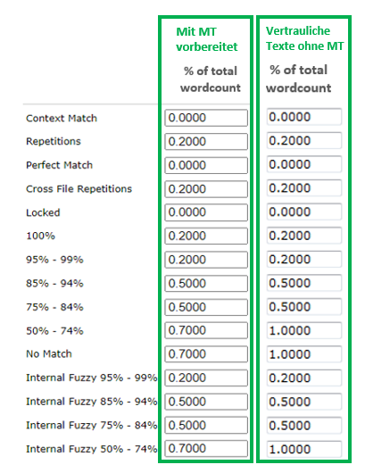
Explanation of match categories:

Internal fuzzy matches:
So-called internal fuzzy matches are fuzzy matches within the file or, in the case of projects involving several files, between the files, which are not taken from the TM but rather arise while the translator is completing the translation.

Example:
Title of the first paragraph: Benefits of VOIP telephony
Title of the second paragraph: Benefits of ISDN telephony
When using an initial empty TM, the second title would produce an internal fuzzy match with a value of around 85%.

Locked segments:
As of Studio 2014, locked segments can be shown separately in the analysis and hence be discounted accordingly.

The segments must be locked before the analysis (e.g., as part of a pre-translation or when using the PerfectMatch function).

Date and signature:

